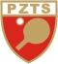
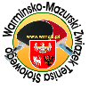
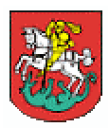
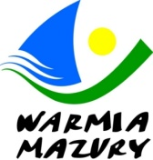
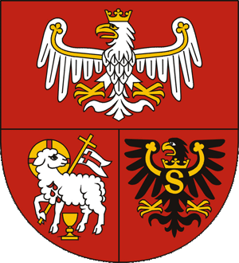
II INTERNATIONAL WARMIA & MAZURY
CADET AND JUNIOR OPEN IN TABLE TENNIS
OSTRÓDA, 12-14.09.2019

PROSPECTUS

- Organizer:
- Marshal of the Warmian-Masurian Voivodeship
- Warmian-Masurian Table Tennis Association (WMZTS)
- Mayor of Ostróda
- Ostróda Sports and Recreation Center
- Aim:
Selection of the best players in categories:
Mini Cadet – 2007 - 2008 and younger
Cadet – 2005 - 2006
Junior – 2002 - 2004
and popularization of the Warmian-Masurian Voivodeship on the national and international arena.
- Event office:
- Ostróda Sports and Recreation Center (Ostródzkie Centrum Sportu i Rekreacji)
ul. Kościuszki 22A, office open: 12-14.09.2019
e-mail: wmzts@wmzts.pl
- 11.09.2019 event office in Hotel Dom Polonia ul. Pieniężnego 6 Ostróda will be open from 16:00. Competition participants will confirm their presence here.
- Entry form (accommodation and catering) should be sent to: wmzts@wmzts.pl not later than 31 August 2019 (after this date, organizer will not guarantee reservation of accommodation and meals)
- For additional information:
email: wmzts@wmzts.pl
Tadeusz Czyczel – tel. 668 140 057, wmzts@wmzts.pl
Joanna Ryba – tel. 690 367 070, wmzts@wmzts.pl
Michał Ogrodniczak – tel. 512 683 967, wmzts@wmzts.pl
- Accommodation and catering:
The organizer guarantees a reservation of accommodation and meals for competitors who will make reservations until 31/08/2019.
Options:
- Hotel DOM POLONII, ul. Pieniężnego 6, Ostróda (about 250 m from the sports hall),
accommodation with full board, 120 PLN per person/day, 100 people
www.hoteldompoloniiostroda.pl
- Hotel PLATINUM, ul. Wyszyńskiego 11A, Ostróda (about 250 m from the sports hall),
accommodation and breakfast, 190 PLN for a double room/day, 80 people
www.hotelplatinum.pl
- Hotel SAJMINO ul. Kajki 6, Ostróda-Kajkowo (2 km from the sports hall),
accommodation and breakfast, 80 PLN per person/day, 60 people (2 or 3-person rooms) www.hotel.sajmino.pl
- Kraina Jezior Gospoda, ul. Olsztyńska 57, Ostróda (2 km from the sports hall),
accommodation and breakfast, 80 PLN per person/day, 30 people (2 or 3-person rooms)
Booking by order of received entries, but the organizer reserves the right to change the type of accommodation booked.
- Place:
- Sports hall: Hala Sportowo-Widowiskowa OCSiR (Sports and Show Hall), ul. Kościuszki 22A, Ostróda
- 16 tables: ANDRO (blue), Balls plastic ANDRO*** (white)
- Participation:
- Players are registered to the Championship in their or older age categories
- The condition to participate in the tournament is to report on the entry form and have current medical examinations
- The championship will be played with the participation of players from China from the Shandong Training Center
- Awards:
- Cups and cash prizes for places 1-4
CATEGORY | I place | II place | III place | IV place
Junior | 200 USD | 150 USD | 100 USD | 100 USD
Cadet | 200 USD | 150 USD | 100 USD | 100 USD
Mini Cadet | 200 USD | 150 USD | 100 USD | 100 USD
- other prizes for places 5-8
- Confirming participation:
- Please return entry form by email attachment not later than 31 august 2019 to Organising Committee, wmzts@wmzts.pl
- In your application include names of players which will be participating (you can make an application to higher age category)
- Game system:
- According to the PZTS regulations.
- Competition program:
- Wednesday, 18:00 - 21:00 - training
- Thursday - competition start at 9:00
- A detailed program of the competition will be delivered to participants upon arrival. It will be also put on the webside: www.wmzts.pl
- Costs:
- Organisational costs are covered by organizers
- Accommodation costs are covered by players (payable in accommodation location)
- Entry fee for players: 10 EURO (for every category). The entry fee is payable to the account of the organizers, account number: 80 1160 2202 0000 0001 6326 6078.
Warmińsko-Mazurski Związek Tenisa Stołowego WMZTS (Warmian-Masurian Table Tennis Association)
- NOTE – The Organiser ensures transport from Ostróda to Warsaw for competition participants to the III Edition of Ping-Pong PGE National on 15.09.2019.

For Organising Committee
WMZTS
Tadeusz Czyczel

