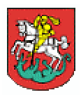
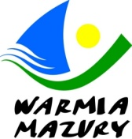
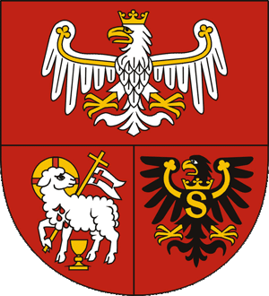
INTERNATIONAL WARMIA & MAZURY
MINI CADET, CADET AND JUNIOR OPEN IN TABLE TENNIS
OSTRÓDA, 12-14.09.2019 r.
ENTRY FORM
ASSOCIATION/ CLUB:

BILLING INFORMATION:

COUNTRY:
CATEGORY  MINI CADET | Name | Date of Birth DD/MM/YYY
BOYS’ | 1.
 | 2.
 | 3.
 | 4.
GIRLS’ | 1.
 | 2.
 | 3.
 | 4.
CATEGORY CADET | Name | Date of Birth DD/MM/YYY
BOYS` | 1.
 | 2.
 | 3.
 | 4.
GIRLS` | 1.
 | 2.
 | 3.
 | 4.
CATEGORY JUNIOR | Name | Date of Birth DD/MM/YYY
BOYS` | 1.
 | 2.
 | 3.
 | 4.
GIRLS` | 1.
 | 2.
 | 3.
 | 4.
TRAINER | Name
 | 1.
TOTAL NUMBER OF PARTICIPANT:
ORGANISING COMMITTEE : wmzts@wmzts.pl
Please return this form by email attachment not later than 31 August 2019 to Organizing Committee
Entry fee for players: 10 EURO
The entry fee is payable to the account of the organizers by 31 August 2019:
80 1160 2202 0000 0001 6326 6078

Organizing Committee guarantee accommodation and breakfast/full board for participants who will register their participation by 31 August 2019:

If you are interested in accommodation please choose one of these option:
- Option 1:
Hotel DOM POLONII, ul. Pieniężnego 6, Ostróda, (250 m from the sports hall)
Accommodation with full board: 120 PLN per person/day (100 people)
Number of people:………………
Date: Arrival: …/09/2019 - Departure: …/09/2019
- Option 2:
Hotel PLATINUM, ul. Wyszyńskiego 11A, Ostróda, (250 m from the sports hall)
Accommodation and breakfast: 190 PLN double room/day (80 people)
Number of people:………………
Date: Arrival: …/09/2019 - Departure: …/09/2019
- Option 3:
Hotel SAJMINO, ul. Kajki 6, Ostróda, (2 km from the sports hall)
Accommodation and breakfast: 80 PLN per person/day (60 people, 2 or 3-person rooms)
Number of people:………………
Date: Arrival: …/09/2019 - Departure: …/09/2019
- Option 4:
Kraina Jezior Gospoda, ul. Olsztyńska 57, Ostróda, (2 km from the sports hall)
Accommodation and breakfast: 80 PLN per person/day (30 people, 2 or 3-person rooms)
Number of people:………………
Date: Arrival: …/09/2019 - Departure: …/09/2019

